REAL MEN BRAND RESOURCES AND GUIDELINES
The logo is our most important brand asset. We use it with consistency and intention to represent a community where men embrace and live out their biblical calling fearlessly.to billions of people around the world.
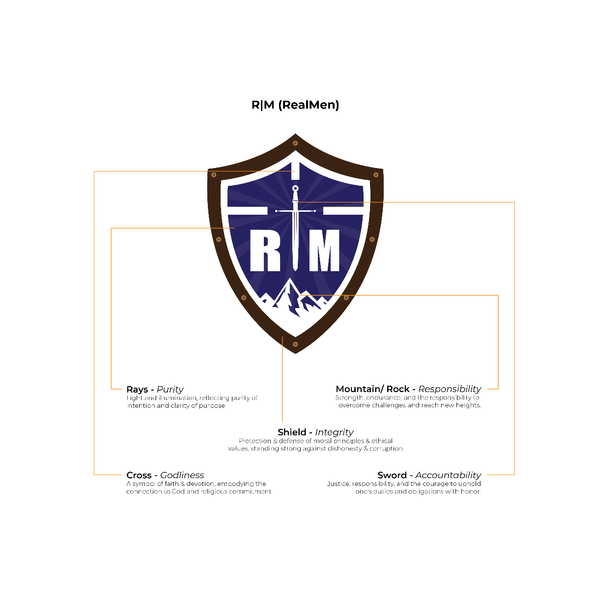
The current logo has been refined in shape and colour to make it more accessible and legible, communicating our core values. Always ensure you are using the current version of our logo in any new designs or communications.

The Real Men logo
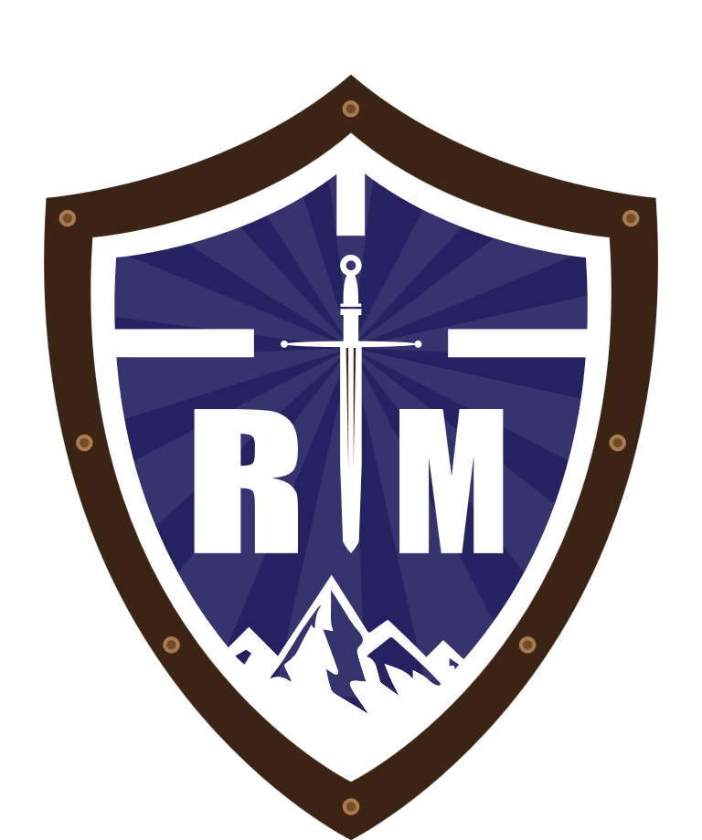
It's important you use this version of the logo. Please contact the administrators and don’t download a logo from a Google search which may be out of date or incorrect.

Primary logo colour
Our primary expression of the logo is a Coffee Brown shield with a Navy-Blue background and white representations of ‘R’ and ‘M’.



SOURCE: CHRISTIAN MENTAL HEALTH COMMUNITY

On white
A Real Men Coffee Brown and Navy-Blue logo on a white background is our primary logo use.

Over imagery
A Real Men Coffee Brown and Navy-Blue logo may also be used over imagery placed with consideration of the image content and contrast. The inner representations including ‘R’ and ‘M’ are always white in this case, never transparent.

Secondary logo colour
Our secondary expression of the logo is in white with transparent inner elements ‘R’ and ‘M’.





On Blue
A white logo on a Navy-Blue/ Coffee Brown background is our secondary logo use.

Over imagery
A white logo may also be used over imagery, but should be placed with consideration of the image content and contrast.

Logo usage
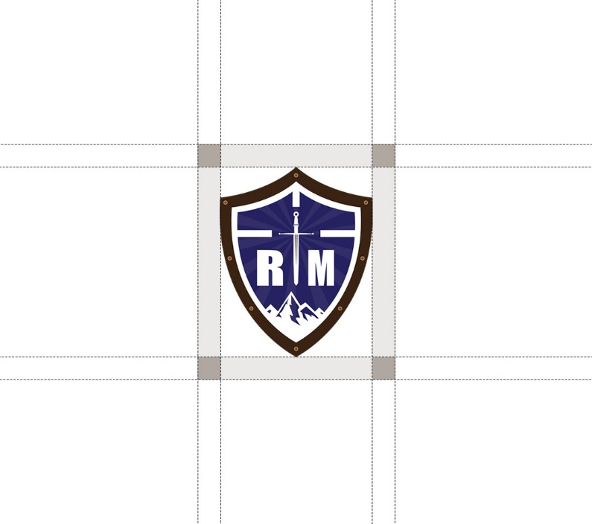
We have a series of rules of how to apply our logo to ensure consistency.

Logo minimum size
The minimum logo size for digital applications is 16px wide. In print, the minimum size is 6mm wide.

Logo watchouts
To prevent our logo from being used in an incorrect way, please avoid using any of the following examples.

- DON'T use our word mark instead of our logo.

- DON'T use just the 'R’ & ‘M' from our logo. The logo must be complete and unaltered.

- DON'T write the word ‘Real Men’ next to the logo

- DON'T add emojis to the logo

- DON'T change the colour of the logo
Do not recolour our logo to your brand colours.
- DON'T make the logo 3D
Do not change the appearance of the logo to 3D.

- DON'T outline the logo
Do not use an outline or any other version of the logo.

- DON'T design your own logo word mark

- DON'T put a drop shadow or effects on the logo

